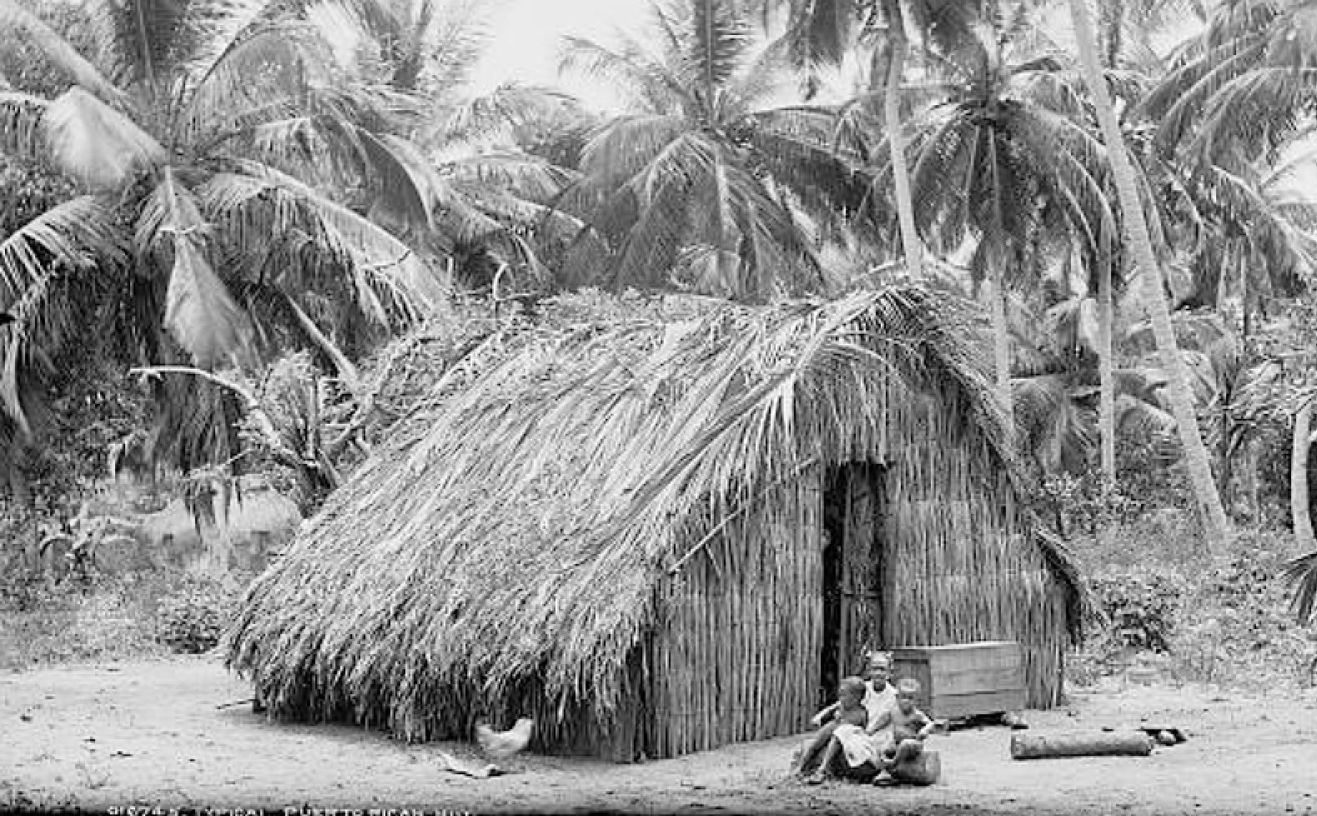

Typical Puerto Rican Hut, ca. 1903